1. Team Membership

Team Name: Cold Fries

Course: EE585

Date: 1/30/2022

| Name (Last, First) | Major(EE, CE, CS) |
| --- | --- |
| Do, Kenny, P969V743 | CE |
| Perez, Kevin, A453B383 | EE |
| Vu, Khai, U326Q228 | CS |
| Nguyen, Michael, P955Z557 | CS |
| Sonexarth, Davin, S555D296 | CS |

1. Team Roles

Include a short description of the role(s) for each team member. Consider the experiences each member brings to the team that will support the project research/design/build phases.

Kenny Do - Circuitry / Team Lead / Co-Project Manager, Will mainly be involved with the design and creation of the project circuitry. In addition to that, will be leading the team in the aspect of meetings, deadlines, task delegation, and making sure all members are fine. Not only will I be working on the circuitry side, but the communication from the Pi to the product. The transmission of data from Pi through IoT will also be heavily worked on in order for the device to properly function. With that, the creation of the housing and the implementation of electrical to the housing.  
  
Kevin Perez - Circuitry / Project Manager / Co-Team Lead, Will mainly be involved with the design and creation of the project circuitry. In addition to that, will be co-leading the team in the task delegation, meetings and checking up on other members. In addition will be responsible for setting up any extra circuitry not completed in first semester. As of now that includes an LED screen, camera and backup battery. I will be looking into the design and production of the mechanical parts and housing of the project’s final design. Any extra time I’ll spend on testing of the design, iterating that design and possible PCB of the circuitry.

Khai Vu - Programmer / Time Keeper, Will mainly be involved with the design and creation of the programming of the project. In addition to that, will be in charge of tracking the minutes, when every topic was talked at a certain time, and when time will be stopped if on a time crunch. In addition will have 3D model finalized and ready to 3D print for final product build.

Michael Nguyen - Programmer / Scribe, I will mainly be involved with the design and creation of programming of the project. I will be compiling the information and knowledge gathered from our research, and implementing it as working code to get our model working. In addition to that, I will be in charge of writing down the topics during meetings, presenting new ideas to the group, and tracking down all important notes whenever presented.

Davin Sonexarth - Programmer / Facilitator / Online Media Organizer, Will mainly be involved with the design and creation of programming of the project. This includes the client side interface for the product, as well as some of the backend that will be involved with creating the product. Will also be working on getting the communications between the product and the user interface. In addition to that, will be in charge of making sure all important and necessary items are present during meetings, setting up and organizing shared resources and storage, simplifying the placement of all online media sources such as proper placement of sources, etc.

Signatures

Each member needs to sign and date the Code of Conduct



Print: _________________________ Print: __________________________ 

Sign: 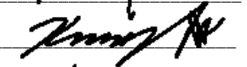 1/30/21 Sign: ___________________________ 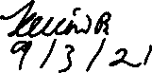

Print: __________Khai Vu_________ Print: __________________________   
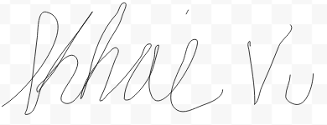

Sign: _________________________ Sign: ___________________________ 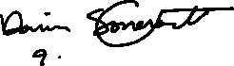

Date: _____1/30/22_______________ Date: __________________________



Print: _________________________

Sign: _________________________

Date: _________________________

The team (including all 5 members) attributes that this document meets their specification for this semester and that the goals we want to attain meet our standards on this day January 30th 2022.